Cabrillo information

The EPC Ukraine DX Contest (EPC-UKR-DX).
Dear Fellow PSK Contester,

You can check and download via the web interface at:

http://ua9qcq.com/contests/robot.php/
CABRILLO QSO TEMPLATE
THE CONTEST COMMITTEE ACCEPTS LOGS IN THE CABRILLO FORMAT ONLY
------ INFO SENT ------- ------ INFO RCVD -------
QSO: FREQ MO DATE TIME CALLSIGN RST NUM CALLSIGN RST NUM
QSO: ***** ** yyyy-mm-dd nnnn ************* nnn nnnnnn ************* nnn nnnnnn
QSO: 14070 RY 2017-12-02 2003 UR0AAA 599 UR01 RK4WWQ 599 001
QSO: 14070 RY 2017-12-02 2007 UR0AAA 599 UR01 DO9ST 599 005
QSO: 14070 RY 2017-12-02 2007 UR0AAA 599 UR01 UN7DA 599 008
QSO: 3580 RY 2017-12-02 2011 UR0AAA 599 UR01 RX9FG 599 007
QSO: 3580 RY 2017-12-02 2016 UR0AAA 599 UR01 UA9WBX 599 008
QSO: 3580 RY 2017-12-02 2017 UR0AAA 599 UR01 UA9TK 599 006
...
QSO: 14070 RY 2017-12-03 1649 4Z5KZ 599 101 RV3QX 599 209
QSO: 14070 RY 2017-12-03 1651 4Z5KZ 599 102 UA6BJY 599 415
QSO: 14072 RY 2017-12-03 1656 4Z5KZ 599 103 SP9DSD 599 051
QSO: 14070 RY 2017-12-03 1719 4Z5KZ 599 104 YO5BYV 599 023
QSO: 14070 RY 2017-12-03 1729 4Z5KZ 599 105 UR4EYA 599 UR05
1234567890123456789012345678901234567890123456789012345678901234567890123456789
Before sending the log, completely fill out the header information in the Cabrillo file.
You can do this while you are setting up the contest information in the logging program, or afterward using a well-known contest checking software such as www.contestlogchecker.com/
A Checklist for Sending UA9QCQ ROBOT.
1) Your callsign is in the log.
2) Your log is in Cabrillo format. If you don't know how to put it in Cabrillo or aren't sure the format is correct, please use the Contest Log Checker software.
3) The contest name in the log should be like this:
CONTEST: EPC-UKR-DX
4) Write to the Cabrillo Header unwind a category:
START-OF-LOG: 3.0
CONTEST: EPC-UKR-DX
CALLSIGN: UR0AAA
CATEGORY-OPERATOR: SINGLE-OP
CATEGORY-BAND: 80M-40M
CATEGORY-TIME: 24-HOURS
NAME: Sergei Zybko
ADDRESS: P.O.Box 66,Sumy,111111,Ukraine
EMAIL: ur0aaa@gmail.com
or
START-OF-LOG: 3.0
CONTEST: EPC-UKR-DX
CALLSIGN: UR0AAA
CATEGORY-OPERATOR: SINGLE-OP
CATEGORY-BAND: 20M-15M-10M
CATEGORY-TIME: 24-HOURS
NAME: Sergei Zybko
ADDRESS: P.O.Box 66,Sumy,111111,Ukraine
EMAIL: ur0aaa@gmail.com
or
START-OF-LOG: 3.0
CONTEST: EPC-UKR-DX
CALLSIGN: UR0AAA
CATEGORY-OPERATOR: MULTI-OP
CATEGORY-TRANSMITTER: ONE
NAME: Sergei Zybko
ADDRESS: P.O.Box 66,Sumy,111111,Ukraineor
EMAIL: ur0aaa@gmail.com
or
START-OF-LOG: 3.0
CONTEST: EPC-UKR-DX
CALLSIGN: UR0AAA
CATEGORY-OPERATOR: SINGLE-OP
CATEGORY-BAND: ALL
CATEGORY-TIME: 24-HOURS
NAME: Sergei Zybko
ADDRESS: P.O.Box 66,Sumy,111111,Ukraine
EMAIL: ur0aaa@gmail.com
or
START-OF-LOG: 3.0
CONTEST: EPC-UKR-DX
CALLSIGN: UR0AAA
CATEGORY-OPERATOR: SINGLE-OP
CATEGORY-BAND: ALL
CATEGORY-TIME: 12-HOURS
NAME: Sergei Zybko
ADDRESS: P.O.Box 66,Sumy,111111,Ukraine
EMAIL: ur0aaa@gmail.com
The screenshot below shows a valid Cabrillo log created by Contest Log Checker.

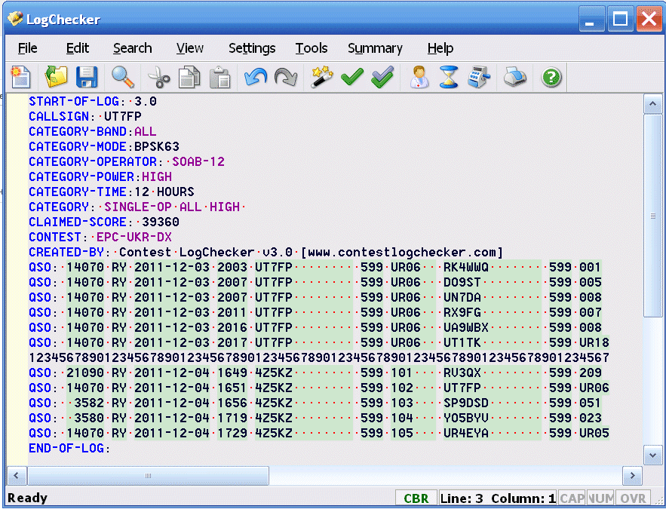

All the very best and see you all in the EPC Ukraine DX Contest !

